REAGEN™

Total Protein Assay Kit
RNN89003

Product Description

REAGEN™ Total Protein Assay Kit is a plate-based colorimetric enzymatic assay for the determination of total protein in serum samples.
The kit uses a spectrophotometric assay to detect total protein directly from serum samples, enabling researchers to detect total protein levels in animal serum and other tissue matrices such as urine and ascites. •
The unique features of the kit are:
- High sensitivity and low detection limit (0.5g/dL)wide linear range .
- A rapid (10minute) and robust enzyme-based assay which does not require expensive instrumentation.
- High reproducibility.

Introduction
Proteins form the major portion of the macromolecular solutes in the blood. Protein in the plasma is primarily comprised of albumin and globulin. Changes in blood protein levels are associated with various disease states. Elevated levels of total protein in plasma have been strongly associated with a variety of diseases involving the liver, kidney, or bone marrow, as well as other metabolic or nutritional disorders. Low serum protein concentrations can be symptoms of overhydration, kidney damage, severe burns, or failure of protein synthesis (starvation, protein malnutrition, or liver cell damage).
REAGEN™ Total Protein Assay Kit is a simple, direct and automation-compatible method for measuring total protein levels in serum samples. This method, commonly referred to as the Biuret assay, is based on the interaction of cupric ion (Cu2+) with protein in an alkaline solution.
Protein + Cu2+ → blue-violet complex
The intensity of the color, and hence the absorption at 540 nm, is directly proportional to the protein concentration. This kit provides direct determination of total protein in serum, plasma, and other fluid samples.
The kit contains sufficient materials to rapidly test 42 serum samples in duplicate. It also comes with a control solution containing a total protein standard which can be used to calibrate the assay .

Procedure Overview
After preparing the sera, the assay is performed by adding Total Protein Reagent into microplate wells containing 6 μL sera. After a brief incubation, the absorbance of each well at 540 nm is then measured using a plate reader. The concentration of total protein in each sample is then directly determined from the 540 nm absorbance.

Kit Contents, Storage and Shelf Life

REAGEN™ Total Protein Assay Kit has the capacity for 96 determinations or testing of 42 samples in duplicate (using 12 wells for standards). Store the kit at 4°C. The shelf life is 6 months after receipt when the kit is properly stored.

Kit Contents | Amount | Storage
Microtiter Plate | 1 | 4°C–30°C
Total protein Standard | 1 vial | 4ºC
Standard Diluent | 4 mL | 4ºC
Total protein Reagent | 30 mL | 4ºC

Required Materials Not Provided With the Kit
- Microtiter plate reader (540 nm)
- Centrifuge to prepare serum samples
- Deionized or distilled water
- 1.5ml microfuge tubes
- 10, 20, 100 and 1000 μL pipettes
- Multi-channel pipette (Optional)

Warnings and Precautions
REAGEN strongly recommends that you read the following warnings and precautions to ensure your full awareness of the techniques and other details you should pay close attention to when running the assays. Periodically, optimizations and revisions are made to the kit and manual. Therefore, it is important to follow the protocol that comes with the kit. If you need further assistance, you may contact your local distributor.
- Add standards to plate only in order from low concentration to high concentration, as this will minimize the risk of compromising the standard curve.
- Anticoagulants such as fluoride and oxalate will result in false low values.
- The assay is not influenced by hemoglobin values up to 200mg/dl or by bilirubin levels up to 10mg/dl.
- Interference from grossly hemolyzed specimens is correctable by use of a serum/plasma blank.

SAMPLE PREPARATION
- Carefully prepare at least 20 µL of sera using standard production procedure (if determinations are performed in singlet then 10 µL is sufficient). Any specimen containing heparin is unsuitable for this test.
2. Serum or plasma Total Protein is reported stable for 7 days when stored at 4°C and 72 hours at room temperature.
Note:
1. Samples with values above 10g/dL should be diluted 1:1 with saline (0.9% NaCl)and re-tested. Multiply results by two.
2. Grossly lipemic serums require a sample blank. Add 5 µLof sample to 250 µL saline, mix, and read the absorbance against water. Subtract this reading value from the absorbance of each serum sample to obtain the corrected reading. PARATION
INOGANIC PHOSPHORUSDETECTION TEST PCOL

INOGANIC PHOSPHORUS DETERMINATION TEST PROTOCOL
Setup
Prewarm reagents to 37°C for 1 hour. Turn on the plate reader and allow the lamp to warm up. Set the temperature of the plate reader to 37°C before reading. Adjust the wavelength of the plate reader to 540 nm.
Be sure that Total Protein Reagent is prewarmed to 37°C before use.
Reagent Preparation
Preparation of Total protein Standard
To reconstitute the Total Protein Standard, add exactly 3 mL of Standard Diluent to the Total Protein Standard. Mix by swirling or inverting the bottle 10 - 12 times. Allow contents to dissolve for 30 minutes at room temperature.
IMPORTANT: The reconstituted Total Protein Standard can be left at room temperature for short periods (up to 4 hours) prior to use. Between uses, the reconstituted Total Protein Standard should be stored frozen at -20 °C (for up to 180 days). Divide the reconstituted Standard into smaller aliquots to avoid repeated freeze/thaw cycles.
Preparation of Total ProteinControl Dilutions for Standard Curve
1. Label 6microfuge tubes: 1, 2, 3, 4, 5, 6.
2. Dilute the Total Protein Standard using Standard Diluent described in the table below. After dilution, briefly mix each tube.
Tube # | Volume Total Protein Standard (6.3g/dL) | Volume Standard Diluent | Total Protein Concentration (g/dL)
1 | 0 µL | 90µL | 0
2 | 15µL | 75 µL | 1.05
3 | 30µL | 60µL | 2.1
4 | 45µL | 45µL | 3.15
5 | 60µL | 30µL | 4.2
6 | 90µL | 0 µL | 6.3
- Use 6µL of each diluted standard per reaction (see below).

Sample Test Procedure
1. Add 6µL of each sample or standard (in duplicate) to the microplate wells.
2. Add 300µL of Reagent Mix to the wells.
3. Incubate at 37°C for 10 minutes.
4. Measure the absorbance of each wellat 540nm.

Total Protein Concentration Calculation
There is a linear relationship between the concentration of Total Protein in the sample and absorbance at 540nm. Therefore, a standard curve used to calculate the Total Protein concentration in sera samples can be constructed by plotting the mean corrected absorbance values for each of the diluted Total Protein standards as a function of Total Protein concentration. The standard curve provides a reference for the linearrange of the assay.
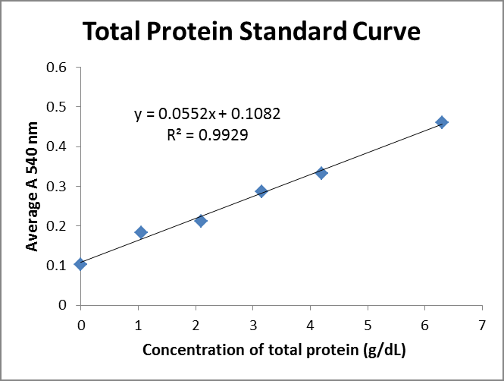

REAGEN LLC
Add.: 102CommerceDr.Unit8,Moorestown,NJ08057
Tel.:856-727-0250 FAX.:856-727-0251
E-mail:reagenkits@gmail.com reagenllc@gmail.com
Web.:www.reagen.us

