REAGEN™
THIOCYANATE ASSAY KIT
RNF91019

Product Description
REAGEN™Thiocyanate Assay Kit is intended to exam thiocyanate adulteration in raw milk samples. Raw milk samples are subjected to protein precipitation. Then the samples are added with diluted substrate solution and the calculation of thiocyanate content based on absorbance determination due to color change caused by the reaction between thiocyanate and chromogenic substrate. In general, this method is suitable for the quality test of dairy products due to its simple operation and accurate results. The limit of detection of Thiocyanate Assay Kit for raw milk is 5ppm.
Kit Contents
1 pouch: 96 microwells | 96 wells (12 eight well strips) in a microwell holder
reagent A | 100 mL/4bottle
Substrate Concentrate | 10 mL/bottle of substrate
6 vials: Thiocyanate Standard | 1.8 mL/vial of Thiocyanate at following concentrations: 0, 5, 10, 20, 50, 100ppm
MATERIALS REQUIRED BUT NOT PROVIDED
Balance: 20g measuring capability
Centrifuge
Microplate reader with 450nm filter

PRECAUTIONS
1. Bring all reagents to room temperature (19º- 27º) before use.
2. Store reagents at 2 to 8°C and protect from light, and do not use beyond expiration date(s). Never freeze kit components.
3. Do not return unused reagents back into their original bottles. The assay procedure details volumes required.
4. Adhere to all time and temperature conditions stated in the procedure.
5. The reagent concentrates are stable as supplied. Once the concentrates have been diluted to working concentration, they are only good for 2-3 hours so only make as enough each reagent as necessary for the number of samples and standards to be quantified.
6. Never pipette reagents or samples by mouth.
7. Wear protective suits, lab glasses and gloves during any time of experiment. Reagents in the kits possess potential hazardous or toxic properties if inhaled or contacted with skin or eyes. See MSDS for details.
8. Dispose of all materials, containers and devices in the appropriate receptacle after use.

SAMPLE PREPARATION
Note: The sample must be collected according to established sampling techniques
- Raw, pasteurized and skim milk: centrifuge 4000rpm 10minutes,get the clear liquor.
1.1 Add 1mL reagent A to 1mL of sample, and mix well by shaking vigorously by hands for 1min.
1.2 Filter the extract through two pieces of Whatman #1 filter paper (or equivalent). Or centrifuge 4000rpm 10minutes
- Note that the two piece of filter paper should be packed together during filtration. Collect the filtrate and the sample is now ready for testing.

ASSAY PROCEDURE
Note: It is recommended that a multi-channel pipettor be utilized to perform the assay. If a single channel pipettor is used, it is recommended that no more than a total of 16 samples and standards (2 test strips) are run.

- Transfer 200uL of each thiocyanate standard to a 96 well plate.
- Transfer 200uL of each prepared samples as instructed by SAMPLE PREPARATION into wells following standard wells.
3. Add 100uL of the substrate reagent to each sample and standard.
4. Measure the absorbance at 450 nm in a microplate reader in no more than 5min.

INTERPRETATION OF RESULTS
Plot the Standard curve using 4-parameter method.
Apply the sample readings to the standard curve to get the concentration of thiocyanate in the reaction wells (Ct).
Raw, pasteurized and skim milk sample thiocyanate concentrations (C) are:
C=Ct ×2
If a sample contains thiocyanate at greater than the highest standard, it should be diluted appropriately in distilled or deionized water and retested.
The extra dilution step should be taken into consideration when expressing the final result.

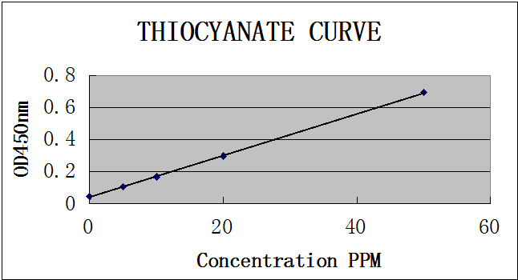
REAGEN LLC
Add.: 102CommerceDr.Unit8,Moorestown,NJ08057
Tel.:856-727-0250 FAX.:856-727-0251
E-mail:reagenkits@gmail.com reagenllc@gmail.com
Web.:www.reagen.us

